1. **Write a program to perform addition of two arrays and print it.**

→

import java.util.Scanner;

public class array

{

public static void main(String args[])

{

Scanner sc = new Scanner(System.in);

int i, size;

int[] a1 = new int[5];

int[] a2 = new int[5];

int[] a3 = new int[5];

System.out.print("Enter size of array : ");

size = sc.nextInt();

System.out.print("\nEnter elements of 1st array : \n");

for(i=0; i<size; i++)

{

System.out.print("a1["+i+"] : ");

a1[i] = sc.nextInt();

}

System.out.print("\nEnter elements of 2nd array : \n");

for(i=0; i<size; i++)

{

System.out.print("a2["+i+"] : ");

a2[i] = sc.nextInt();

}

System.out.print("Addition : ");

for(i=0; i<size; i++)

{

a3[i] = a1[i] + a2[i];

System.out.print("\na3["+i+"] : "+a3[i]);

}

}

}

**o/p :**

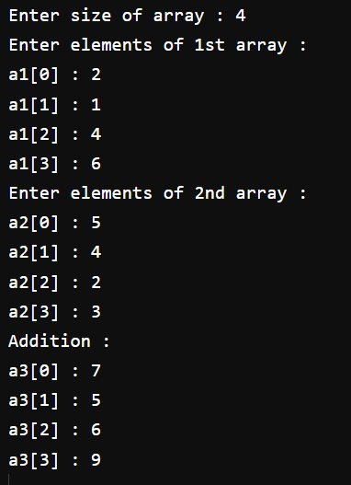

1. **Write a program to perform matrix multiplication.**

→

import java.util.Scanner;

public class MatrixMultiplication {

public static void main(String args[]) {

int row, col, i, j, k, sum=0;

Scanner input = new Scanner(System.in);

System.out.print("Enter the number of rows of matrix : ");

row = input.nextInt();

System.out.print("Enter the number of columns of matrix : ");

col = input.nextInt();

int m1[][] = new int[row][col];

int m2[][] = new int[row][col];

int m3[][] = new int[row][col];

System.out.println("Enter elements of first matrix : ");

for (i = 0; i < row; i++)

{

for (j = 0; j < col; j++)

{

m1[i][j] = input.nextInt();

}

}

System.out.println("Enter elements of second matrix : ");

for (i = 0; i < row; i++)

{

for (j = 0; j < col; j++)

{

m2[i][j] = input.nextInt();

}

}

for (i = 0; i < row; i++)

{

for (j = 0; j < col; j++)

{

for (k = 0; k < row; k++)

{

sum = sum + m1[i][k] * m2[k][j];

}

m3[i][j] = sum;

sum = 0;

}

}

System.out.println("Multiplication : ");

for (i = 0; i < row; i++)

{

for (j = 0; j <col; j++)

{

System.out.print(m3[i][j]+"\t");

}

System.out.print("\n");

}

}

}

**o/p :**

